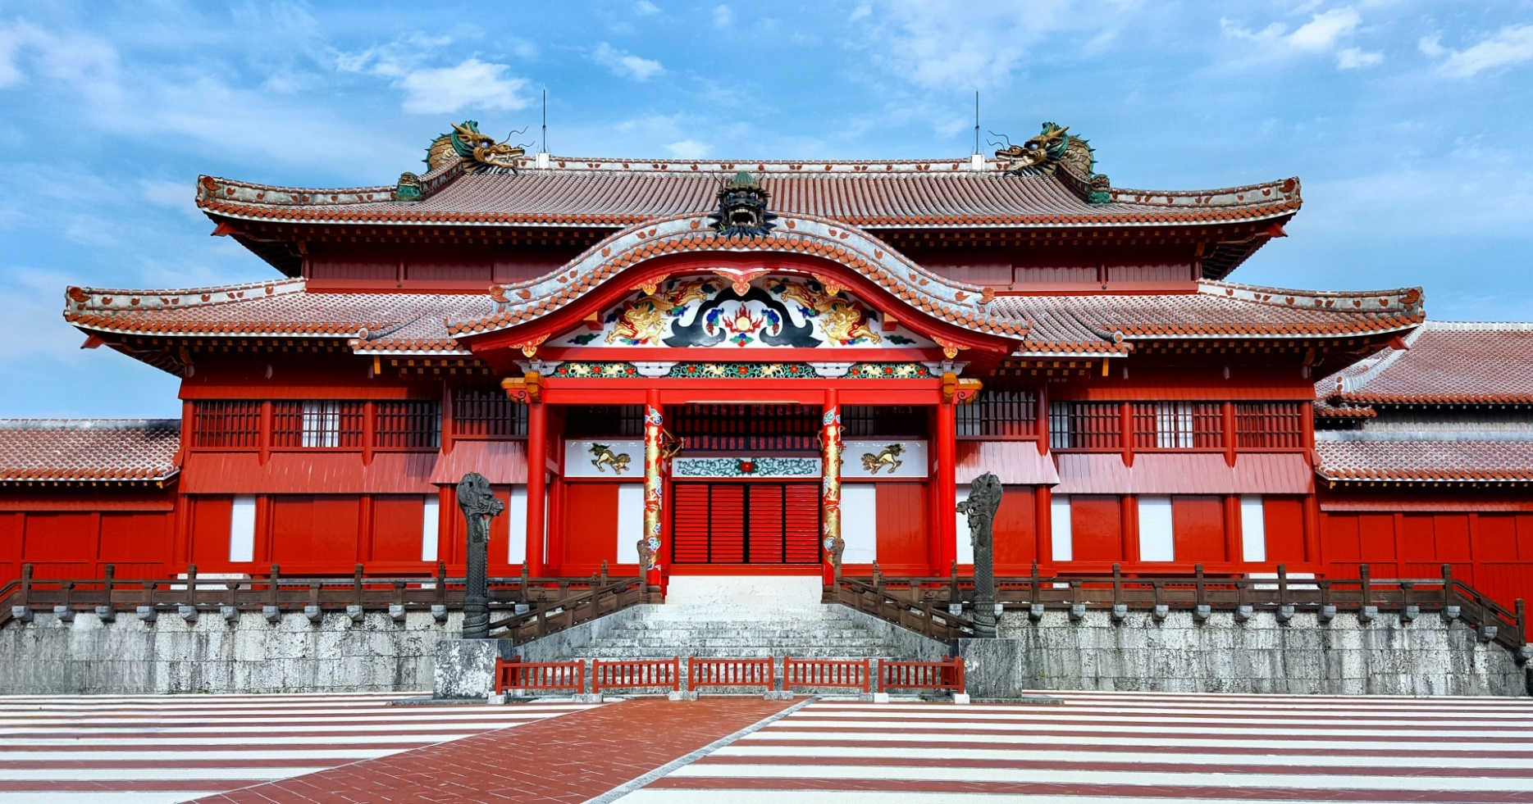

ICLC Uchinanchu

Youth Scholarship Program

S

October 2024

Application Guide

About ICLC

Who we are
ICLC (International Center for Language and Culture) was established in 1983 and is the oldest Japanese language school in Okinawa.
The school's history began at a time when Okinawan descendants (uchinanchu) born overseas returned to Okinawa to explore their family roots and visit relatives. Our first programs were to provide Japanese language education to them and to help them adjust to Okinawa and Japanese society. To date, we have accepted students from various countries, and with our many years of experience and knowledge, we continue to offer opportunities to students to achieve their needs and goals.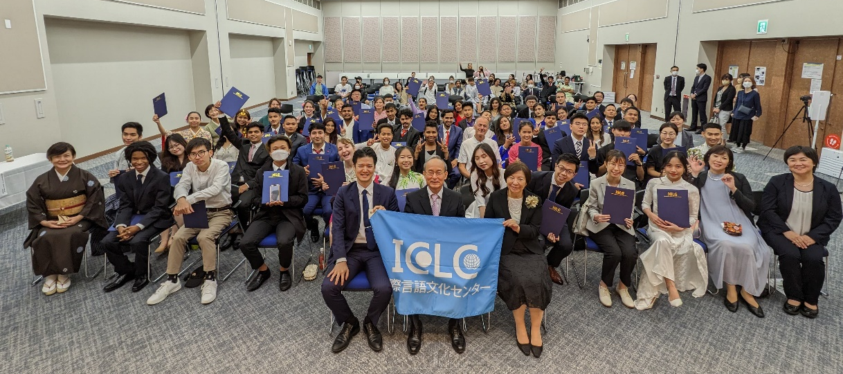

Purpose of this Program
This scholarship program was launched to commemorate the 40th anniversary of ICLC. Descendants of Okinawans who left for the world as immigrants continue activities to discover their Okinawan identity and pass on the culture. We established this scholarship program primarily to focus on these young uchinanchus to expand and strengthen the uchinanchu network in various communities around the world.
We hope this scholarship will provide an opportunity for the future leaders of uchinanchu communities to learn Japanese and experience life in Okinawa.

Program Details
Students will be enrolled as regular students at ICLC Okinawa Japanese Language School.
We expect students to be highly motivated to study the language and engage in Japanese and Okinawan culture.
Students are also encouraged to participate in activities outside of school and become involved in local Okinawan communities and groups.

About Classes
ICLC offers two types of classes.
Comprehensive Japanese Class
Classes will focus on learning the 4 skills (listening, speaking, reading, writing) and JLPT preparation. This class is designed for students who wish to enter higher education or apply for jobs in Japan.
*JLPT (Japanese Language Proficiency Test) is an official language certification test that serves as proof of one’s Japanese linguistic skills when applying to higher education and companies in Japan.
*For beginners of Japanese language, 150 hours of Japanese language study experience is required before joining this class.

Introductory Japanese Class
Students will learn essential expressions and vocabulary centering on conversation skills with the aim of acquiring daily life Japanese. This class is mainly designed for students starting out fresh. After reaching beginner level 3, students can join the intermediate level in the comprehensive class.

Class Schedule
Students will be placed in either AM or PM classes according to their Japanese level.
AM Class：8:45~12:00 (90min. class + 15min. break + 90min. class)
PM Class：13:15~16:30 (90min. class + 15min. break + 90min. class)
*Class hours may slightly change depending on the curriculum.

Scholarship Details
 | Full Scholarship | Half Scholarship
Start of School | October 2024 | October 2024
Study Length | 1 year | 1 year
Award | 100% of tuition | 50% of tuition
Intake | 3 students | 3 students

Expenses NOT covered by scholarship

Full Scholarship Recipients
- Initial fees: visa application fee, entrance fee, insurance and health checkup fee
- Others: flight fee, rent, living fees

Half Scholarship Recipients
- 50% of tuition
- Initial fees: visa application fee, entrance fee, insurance and health checkup fee
- Others: flight fee, rent, living fees

Other matters to note

About program extension
Scholarships cannot be extended. Students who wish to continue their studies may choose to do so at their own expense.

About working part-time
Students with a student visa are legally allowed to work up to 28 hours per week. During long school vacations, students may work up to 40 hours per week.

About housing
Students may choose to live in the dormitories managed by ICLC or find their own housing through relatives or a local real estate agent.

Application Details

Applicant Requirements
- Those with family roots in Okinawa (non-Japanese nationals).
- Those who are 33 years old or younger at time of application.
- Those who are physically and mentally healthy.
- Those who have a clear motivation to learn about Okinawa and its culture.
- Those who are motivated to study Japanese.
- Those who agree to cooperating in public relations activities related to this program.
*Social media posts, TV interviews, etc.
- Those who agree to ICLC’s school terms. (*See page 8)
- Applicants who meet the visa requirements below:
a. Those who have completed high school education or higher
b. Those who have a financial sponsor (family member/relative or self-sponsor)
c. The sponsor must have enough living funds (2 million yen in bank account)

Application Documents

Full Scholarship
- Personal History & Reason for Study (Download from website)
- Materials showing activities and achievements (Download from website)
Present examples of your achievements and participation in Kenjinkai activities,
Okinawa-related events/clubs, or individual activities related to Okinawan culture.
- Recommendation Letter from your Kenjinkai (Download from website)
- Diploma from last educational background
- Academic transcript from last educational background

Half Scholarship
- Personal History & Reason for Study (Download from website)
- Diploma from last educational background
- Academic transcript from last educational background

Schedule of Application and Admission

Scholarship Application Schedule
Submission of Documents | Dec. 15th, 2023 (Fri.) ~  ~ Jan. 31st, 2024 (Wed.) 24:00 (Japan Time)
1st Screening Result (documents) | Feb. 9th (Fri.), 2024
2nd Screening (interview) | Feb. 13th(Tue.) ~ Feb. 29th (Thu.), 2024
Selection Result | Mar. 15th (Fri.), 2024
*The date of the online interview will be notified by e-mail to those who have passed the 1st screening. In principle, all applicants are expected to take the interview on the allotted schedule.

Visa Application
Visa Application Fee Payment | Mar. 18th (Mon) ~ Mar. 29th (Fri.), 2024
Submission of Visa Documents | Apr. 1st (Mon) ~ May. 10th (Fri.), 2024
Issuance of COE | Aug. 23rd (Fri.), 2024
Payment of Initial School Fees  （Entrance, tuition, dorm, etc.） | Aug. 26th (Mon.) ~ Aug. 31st (Fri.), 2024
Complete Immigration Procedure*  （At local embassy or consulate） | Aug. 26th (Mon.) ~ Mid-September, 2024
Enter Japan | Oct. 1st (Tue.) ~ Oct. 8th (Tue.), 2024  *Dorm entry: Oct. 4th (Fri.), 7th (Mon.), 8th (Tue.)
Entrance Ceremony | Oct. 9th (Wed.), 2024
*Please complete immigration procedures at the Japanese embassy or consulate in your country of residence, bringing your COE (Certificate of Eligibility) and necessary documents.

Breakdown of expenses not covered by scholarship
 | Full Scholarship | Half Scholarship
Visa Application Fee | 22,000 yen | 22,000 yen
Entrance Fee | 77,000 yen | 77,000 yen
Insurance, health check | 18,000 yen | 18,000 yen
50% of tuition |  | 387,000 yen
Total | 117,000 yen | 504,000 yen
*Dorm fees are charged separately.

How to Apply

Application Page
https://www.iclc-uchinaa-program.com

Scholarship Application
- Submit application form on Application Page.
- Prepare and submit required documents following instructions from reply email:
iclc-admin@iclcjapan.com

Contact
ICLC Okinawa Japanese Language School
Staff Name: Melissa
Mail：iclc-admin@iclcjapan.com
Tel：098-859-3881

Other Media
ICLC Official School Website：https://iclcjapan.com
Instagram：https://www.instagram.com/iclc_okinawa/

ICLC School Rules and a Written Pledge

All ICLC students must follow the school rules as written below.
Please read the rules thoroughly and follow them to enjoy your time in ICLC.

□Admission Process
A candidate who would like to enter ICLC must submit necessary documents such as an application for admission, a personal history, and other documents by the deadline specified by ICLC. If the documents are not submitted by the deadline, we might cancel your admission.

□Leave of Absence, Returning, Withdrawal, and Removal from ICLC
- In general, it is not allowed to take a leave of absence for personal reasons while the school is in term. If you need to be absent for more than 3 days, you need to submit an application for a leave of absence and medical certificate if necessary.
- Students who took a leave of absence and wish to return to school, may do so by notifying the principal and obtaining permission.
- If you need to withdraw yourself from ICLC, you need to get an approval from the principal and complete all necessary process. If you do not complete the process, you will be removed from our school.
- If a student does not accept withdrawal, our principal may remove the student from ICLC.

□Certificate of Completion and Graduation
- You will be evaluated according to your test scores, attendance rates, and class attitude. If the evaluation meets our school requirements, we will certify your completion or graduation from the course.
- The principal will grant a certificate to those who have completed or graduated from ICLC.
- If there is any outstanding debt upon completion or graduation, the certificate will not be granted.

□Payment and Arrears
- The payment for school tuition must be made by the 20th of a previous month of the next term. A student must make a payment by 3 months in Okinawa and 6 months in Tokyo by the due dates as shown below.
Period | Due Date
Tuition for 4/1～6/30 | 3/20
Tuition for 7/1～9/30 | 6/20
Tuition for 10/1～12/31 | 9/20
Tuition for 1/1～3/31 | 12/20

- A student is not allowed to attend any class unless the payment is completed. Moreover, if arrears are not resolved for more than a month and there is no possible payment plan, we will contact the student’s financial sponsor and also may remove the student from ICLC. A payer will bear any fees related to the payment.

□Classes and Attendance Rates
- In order to avoid future disadvantages to students and maintain good class dynamics, all students must put the best effort into keeping the attendance rates high. ICLC teachers and staffs are going to have meetings with students whose attendance rates are low to remind them the importance and warn them of the possible consequences.
- If the attendance rates do not improve even after the meeting, we will contact the student’s financial sponsor to remind the importance and the possible consequences.
- All students must take the examination for next term at the end of each term.
Class arrangements may be changed (e.g. morning class to afternoon class) according to the result of the examination.

□Removal from ICLC
ICLC may remove students with following criteria from our school.
- Students who made false statements to ICLC including on the documents before entering
- Students whose conducts do not meet ICLC’s standards and have no possibility for improvements
- Students whose academic abilities do not meet ICLC’s standards and have no possibility for improvements
- Students who miss classes without reasons which ICLC consider them valid
- Students who disturb the school order and neglect their duties as students
- Students who fail to pay school fees by the due dates and have no possible payment plan even after receiving a reminder
- Students who break Japanese law
- Students who cannot attend classes because of health issues
- Students who insult or discriminate against another student because of his/her specific ethnicity, nationality, race, creed, religion, gender, sexual orientation, appearance, etc.
□Health Checkup and Insurance
- There is a mandatory health checkup once a year. *Short-term students are exempt
- By Japanese law, all students must join Japanese National Health Insurance and bear the cost. * Short-term students are exempt
- Students who use motorcycles or cars on a daily basis, including commuting to and from school, will not be permitted to use them unless they have voluntary insurance as well as liability insurance. The school will issue warnings to students for unauthorized use. If the student ignores the warning and continues to use the vehicle, he/she will be deemed to have no intention of abiding by the school rules and will be expelled from the school.

I hereby promise to follow all the articles on “Admission Information” and “School Rules and A Written Pledge” upon entering ICLC. I will accept any punishment without an objection if I break my promise.
I grant permission to ICLC to use pictures or videos of myself on the school website, social media, and publications for the purpose of school promotion.

